Country Analysis Project: Part A

This is Part A of the Country Analysis Project.
Please include the graphs provided by the websites! Failure to do so will result in half the points being subtracted from your grade.
The country you should write about is:
Saudi Arabia

Culture: (12 points total)

- Using the tools at https://geerthofstede.com/culture-geert-hofstede-gert-jan-hofstede/6d- model-of-national-culture/ and https://www.hofstede-insights.com/product/compare- countries/, CHOOSE Saudi Arabia and COMPARE them among only the four HOFSTEDE dimensions presented on the website and in class. Provide the following:
  - a short explanation of each dimension, (4 points) and
  - an explanation of how the dimension applies to the country, (8 points).
  - Copy the charts on your paper as well

  - 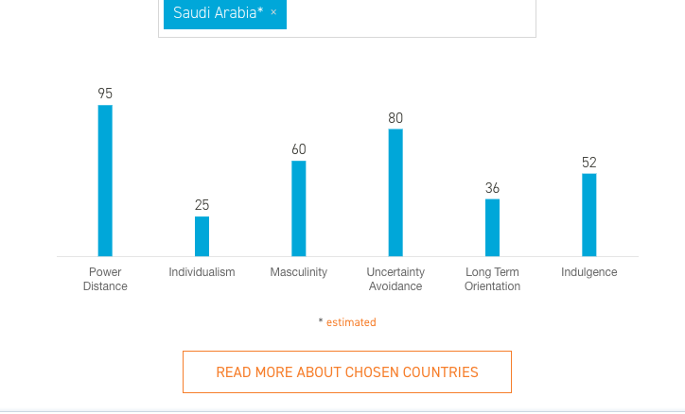
  - explain each on on the chart except LONG TERM ORIENTATION, AND INDULGENCE
  - click on read more about chosen countries to answer all the questions. Your only resource is the site I provided on #1.

Ethics: (8 points total)

- Go to Transparency International, https://www.transparency.org/country and compare your country’ Corruption Perception Index scores (see Question 1), with that of the USA. Why or why not is your country’s score lower than that of the USA? Provide the following:
  - A brief explanation of how the Corruption Perception Index is created, including what a high score and what a low score means. (2 points)
  - Saudi Arabia’s score compared with the score of the USA (2 points),
  - A brief explanation as to why your country’ scores are different than the USA’s score. (2 points)

